- Create a Simple Pod Using YAML Task: Write a YAML file to create a Pod named firstpod with an nginx container. Verify the Pod creation using kubectl get pods and check the logs of the container using kubectl logs firstpod.

Step 1 : Create a YAML File

vi firstpod.yaml

Paste the following YAML configuration:

apiVersion: v1
kind: Pod
metadata:
name: firstpod
spec:
containers:
- name: nginx-container
image: nginx
ports:
- containerPort: 80

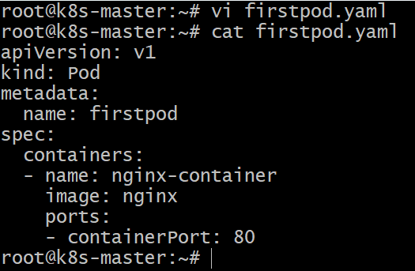

Step 2 : Create the Pod

Run this command to create the pod from the YAML file.

kubectl apply -f firstpod.yaml

Step 3 : Verify Pod Creation

Check whether the pod is running.

kubectl get pods

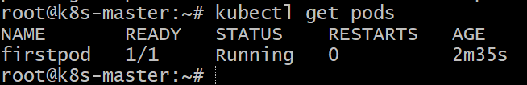

Step 4 : Get Detailed Pod Information

To see detailed information about the pod:

kubectl describe pod firstpod

This shows:
* Pod events
* Container details
* Image used
* Node info
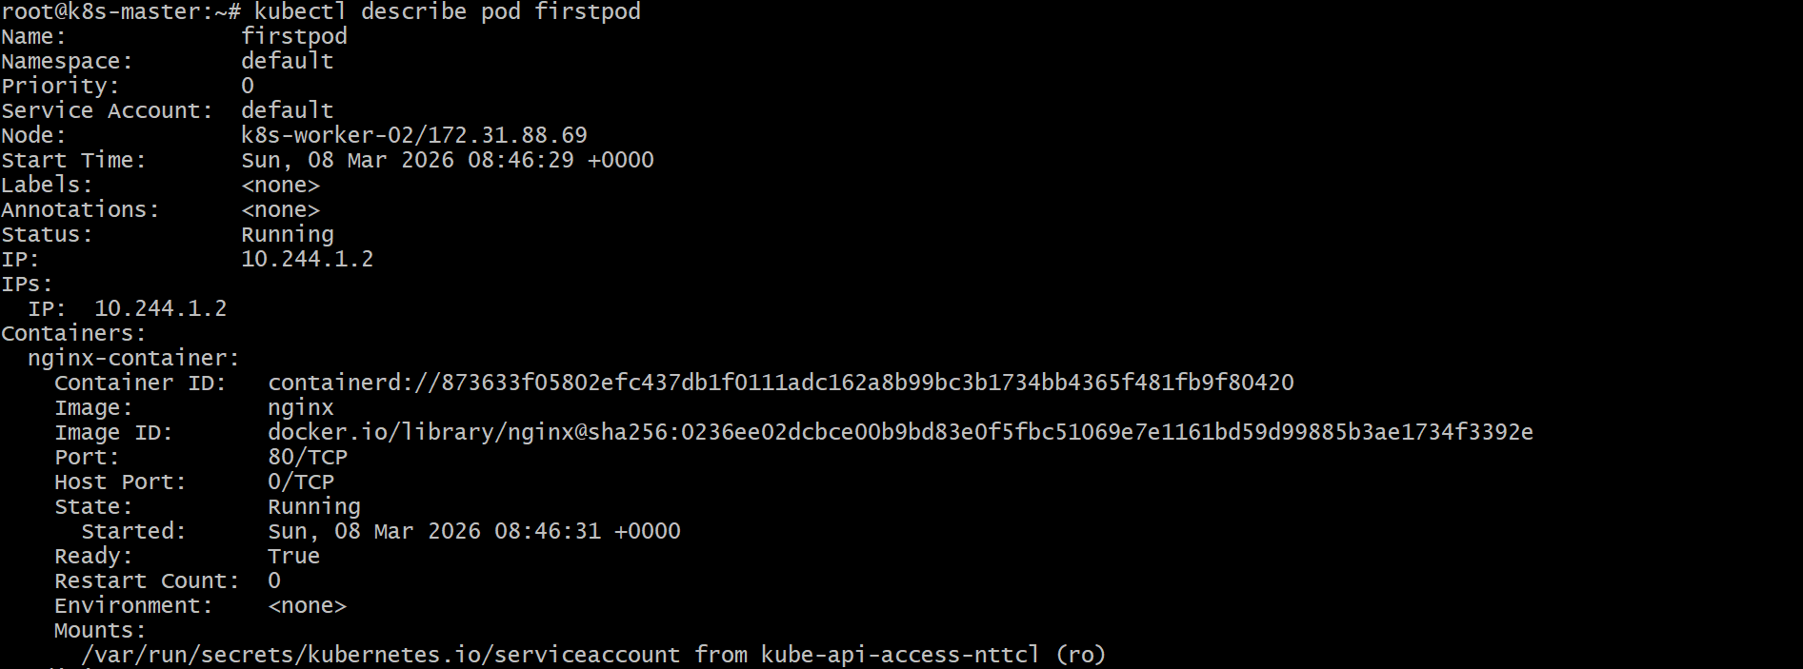
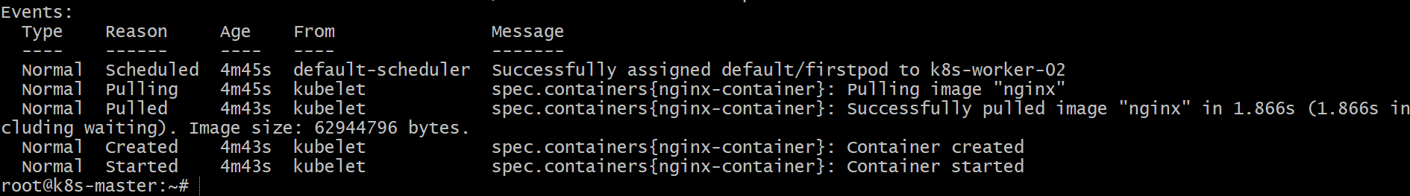

Step 5 : Check Container Logs

kubectl logs firstpod

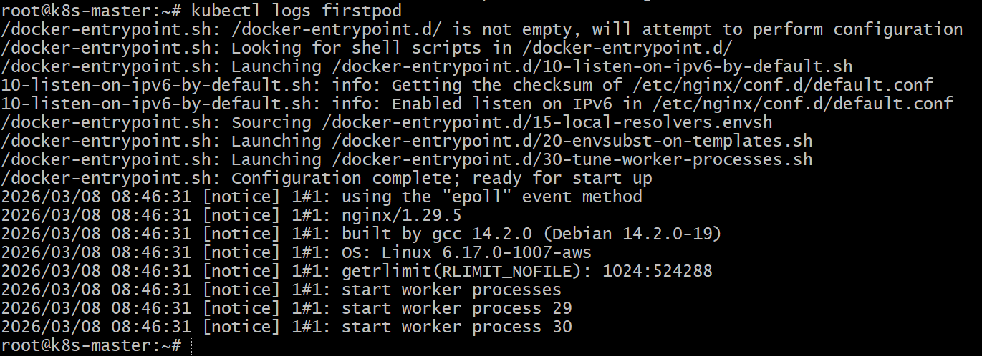

Step 6 : Verify Container Inside the Pod

To open a shell inside the pod:

kubectl exec -it firstpod -- /bin/bash
Or sometimes
kubectl exec -it firstpod -- /bin/sh

Then run:

curl localhost

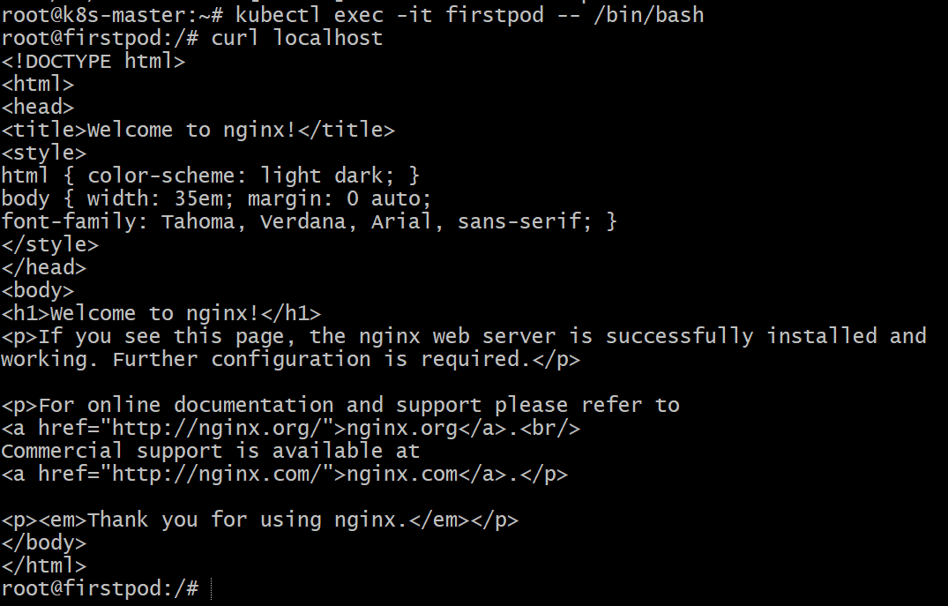

- Set Environment Variables in a Pod Task: Modify the YAML file to include environment variables myname: sabair and City: Hyderabad. Deploy the Pod and use kubectl exec <pod_name> -- env to check if the environment variables are set properly.

Step 1 : Create a YAML File

vi envpod.yaml

Paste the following YAML configuration:

apiVersion: v1
kind: Pod
metadata:
name: envpod
spec:
containers:
- name: nginx-container
image: nginx
ports:
- containerPort: 80
env:
- name: myname
value: sabair
- name: City
value: Hyderabad

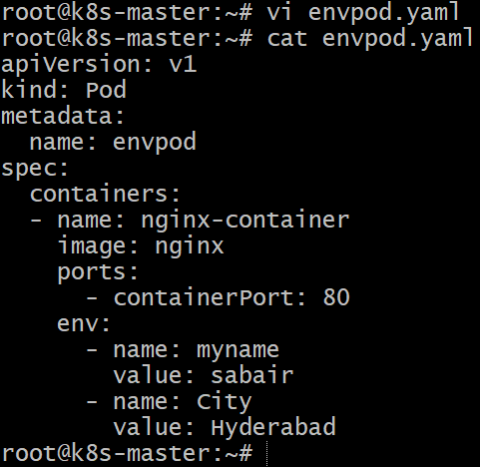

Step 2 : Create the Pod

Run this command to create the pod from the YAML file.

kubectl apply -f envpod.yaml

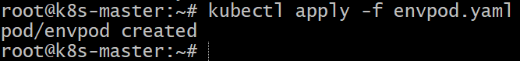

Step 3 : Verify Pod Creation

Check whether the pod is running.

kubectl get pods

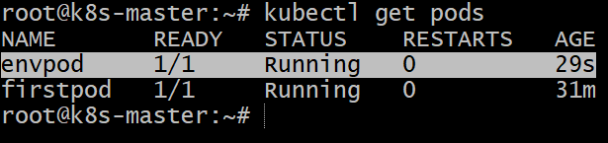

Step 4 : Check Environment Variables inside the Pod

Run the following command:

This will display all environment variables.

kubectl exec envpod -- env

To check a specific variable

kubectl exec envpod -- printenv myname
kubectl exec envpod -- printenv City
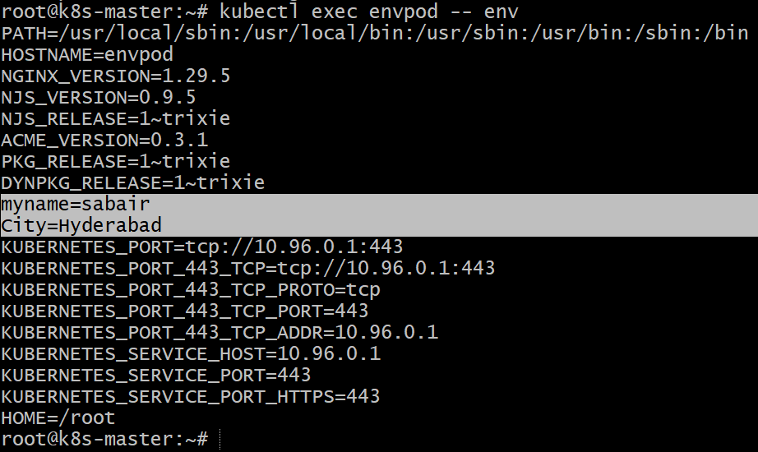

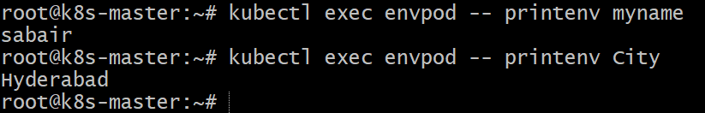

- Deploy a Pod with Commands (Args) in YAML Task: Modify the YAML file to add args that instruct the container to sleep for 50 seconds. Deploy the Pod and use kubectl describe pod to verify the args are correctly passed to the container.

Step 1 : Create a YAML File

vi sleep-pod.yaml

Paste the following YAML configuration:

apiVersion: v1
kind: Pod
metadata:
name: sleeppod
spec:
containers:
- name: sleep-container
image: busybox
command: ["sleep"]
args: ["50"]

Explanation:
image: busybox → small Linux image used for simple commands
command: ["sleep"] → command executed inside the container
args: ["50"] → tells the container to sleep for 50 seconds

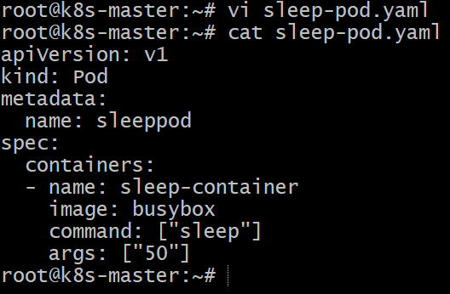

Step 2 : Create the Pod

Run this command to create the pod from the YAML file.

kubectl apply -f sleep-pod.yaml

Step 3 : Verify Pod Creation

Check whether the pod is running.

kubectl get pods

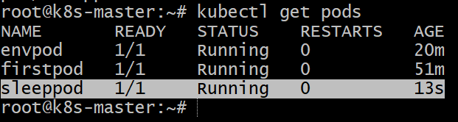

Step 4 : Describe the pod

Use the following command to verify the args:

kubectl describe pod sleeppod

Check the Args in the output.
This confirms the args were correctly passed to the container.
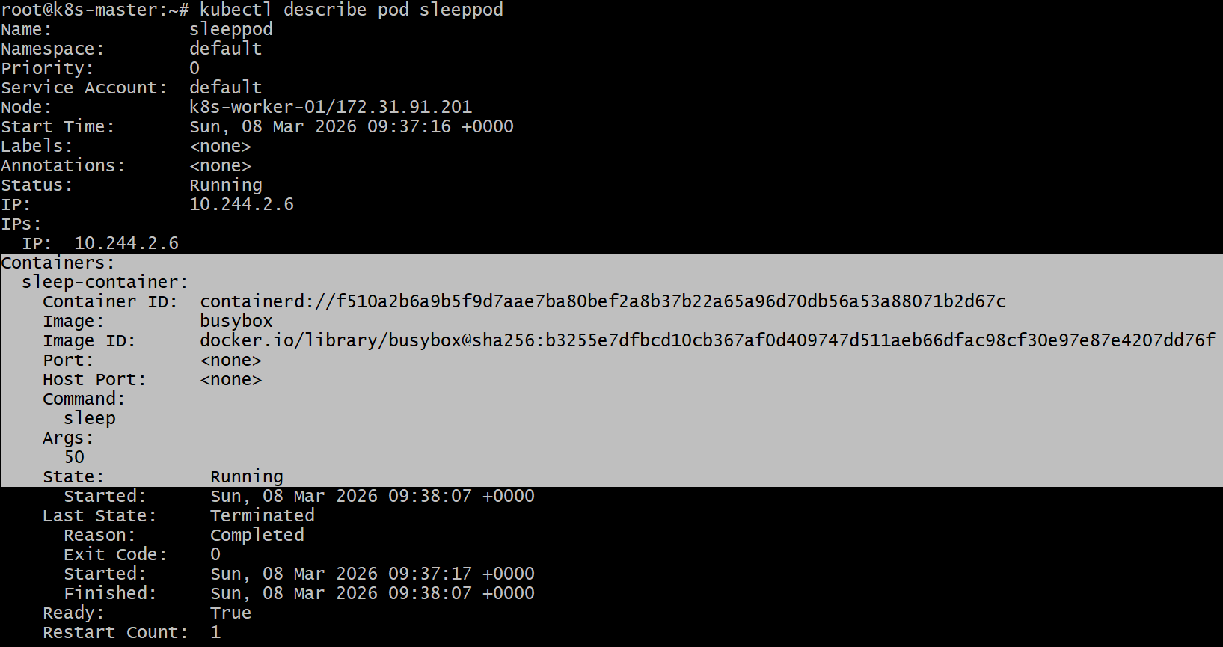

- Create a Pod with Two Containers Task: Create a YAML file to define a Pod with two nginx containers inside. Use kubectl exec to access both containers and verify that both containers can communicate through the same network (e.g., using telnet between them).

Step 1 : Create a YAML file

Create a file named ‘twocontainerpod.yaml’

vi twocontainerpod.yaml

Paste the following YAML:

apiVersion: v1
kind: Pod
metadata:
name: twonginxpod
spec:
containers:
- name: nginx1
image: nginx
ports:
- containerPort: 80

- name: nginx2
image: nginx
command: ["/bin/sh","-c"]
args:
- echo "server { listen 81; location / { root /usr/share/nginx/html; index index.html; } }" > /etc/nginx/conf.d/default.conf && nginx -g 'daemon off;'
ports:
- containerPort: 81

Save the file.

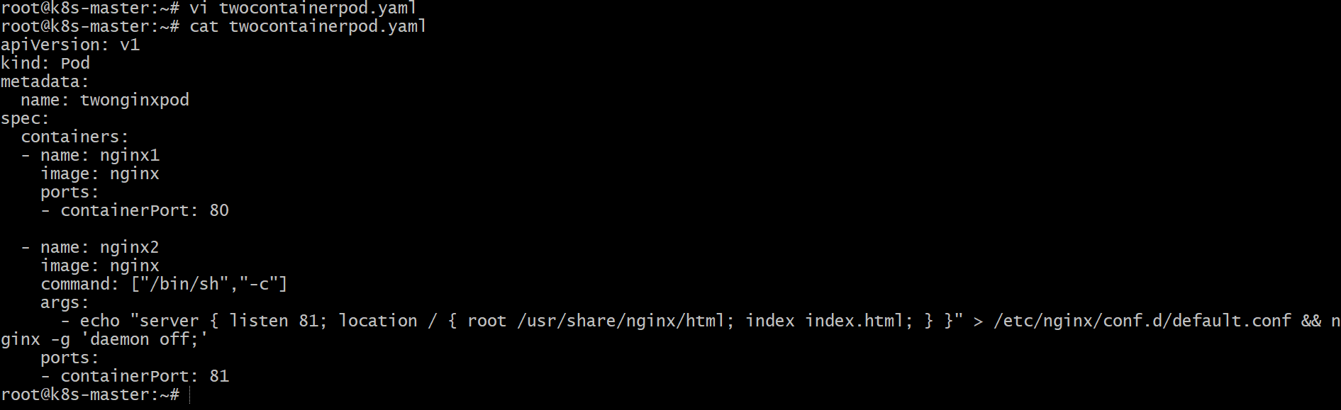

Step 2 : Deploy the Pod

kubectl apply -f twocontainerpod.yaml

Step 3 : Verify the Pod

Check if the pod is running:

kubectl get pods

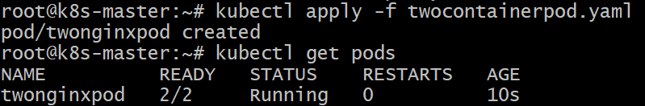

2/2 means both containers are running.

Step 4 : See container details

kubectl describe pod twonginxpod

You will see both containers:
Containers:
nginx1
nginx2

Step 5 : Access Container 1

Run:

kubectl exec -it twonginxpod -c nginx1 -- /bin/bash

Install telnet if needed:

apt update -y
apt install telnet -y

Step 6 : Test communication inside the Pod

Both containers share the **same network namespace**, so they communicate using **localhost**.

Run:

telnet localhost 80

If successful you will see something like:

Connected to localhost

This means the **other container nginx server is reachable**.

Step 7 : Access the second container

kubectl exec -it twonginxpod -c nginx2 -- /bin/bash

Test again:

curl localhost

You should see the **Nginx welcome HTML page**.

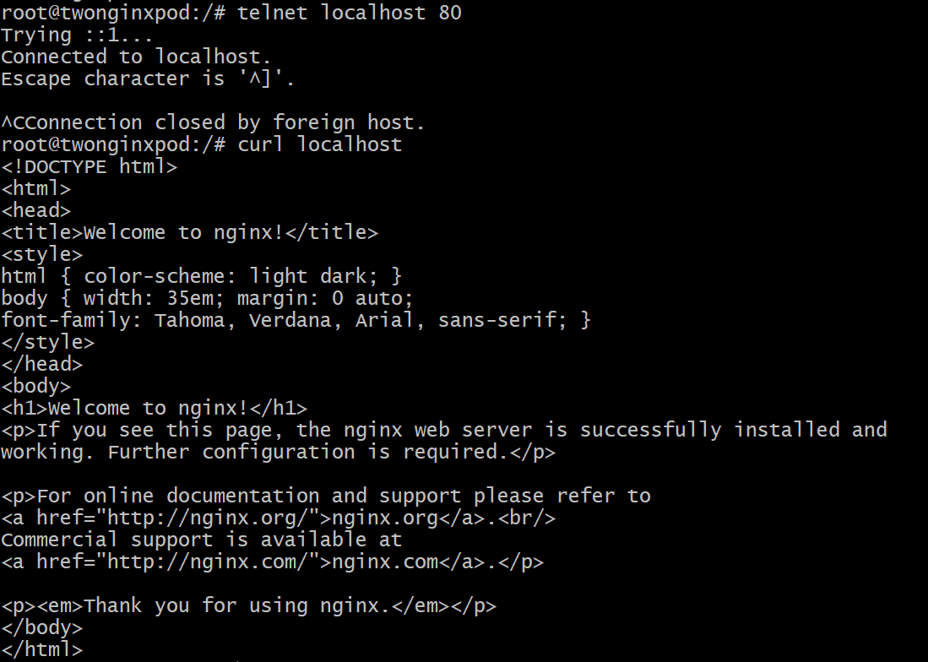

- Set Up an Init Container in a Pod Task: Modify the YAML to include an init container that sleeps for 30 seconds before the main containers start. Verify the init container's execution using kubectl describe pod and check the logs to confirm its completion.

Step 1 : Pod YAML with Init Container

vi init-pod.yaml

Paste the following YAML configuration:

apiVersion: v1
kind: Pod
metadata:
name: init-demo-pod
spec:
initContainers:
- name: init-sleep
image: busybox
command: ["sh", "-c", "echo Init container starting... && sleep 30 && echo Init container completed"]

containers:
- name: main-container
image: nginx
ports:
- containerPort: 80

### Explanation

* initContainers run before the main containers.
* Kubernetes waits for init container completion before starting normal containers.
* `sleep 30` delays startup for 30 seconds.

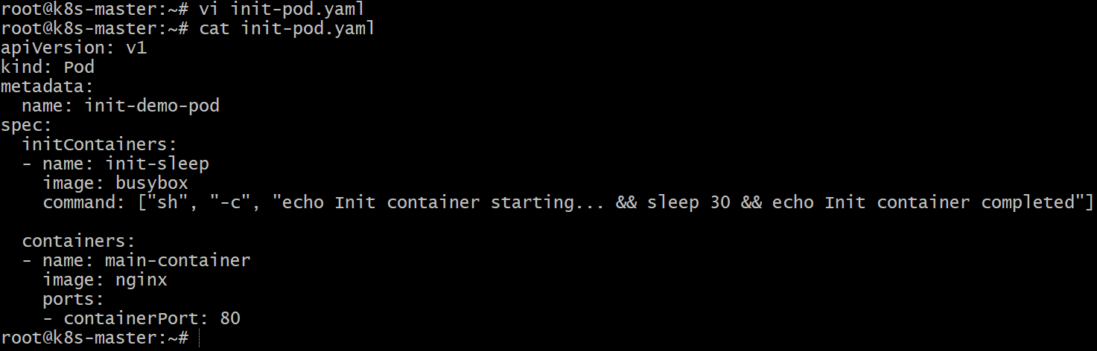

Step 2 : Create the Pod

kubectl apply -f init-pod.yaml

Check pod status:

kubectl get pods

Initially you may see:

init-demo-pod 0/1 Init:0/1

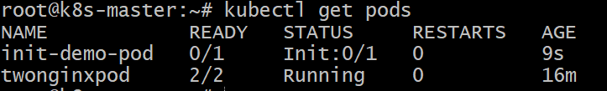

After 30 seconds:

init-demo-pod 1/1 Running

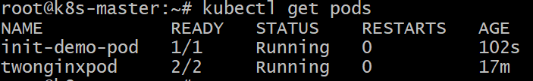

Step 3 : Verify Using `kubectl describe`

kubectl describe pod init-demo-pod

Look for the **Init Containers section**:

```
Init Containers:
init-sleep:
Container ID: ...
Image: busybox
State: Terminated
Reason: Completed
```

This confirms the **init container executed successfully**.

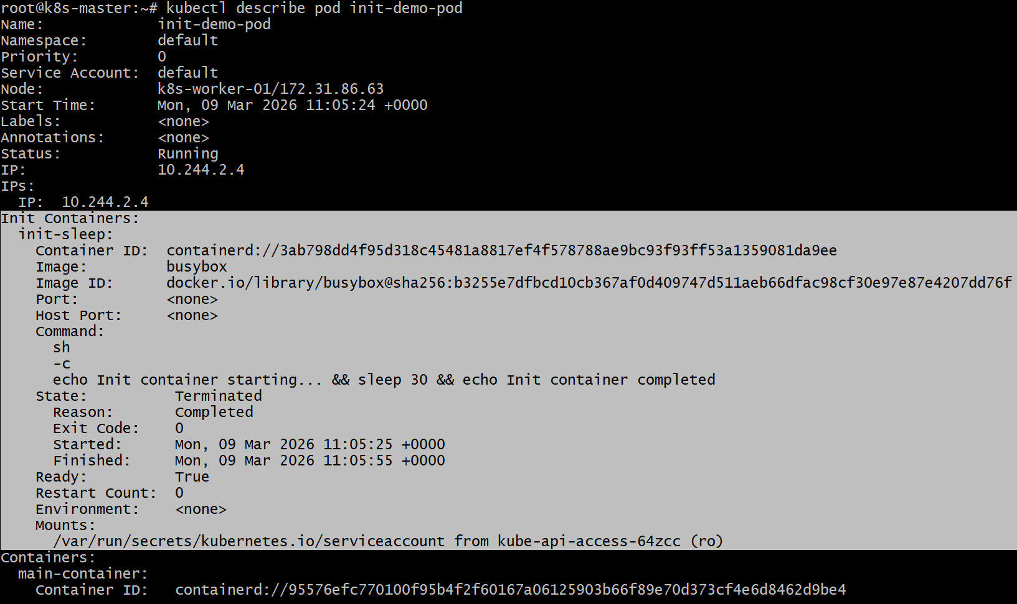

Step 4 : Check Init Container Logs

kubectl logs init-demo-pod -c init-sleep

Expected output:

Init container starting...
Init container completed

This proves the **init container ran before the main container**.

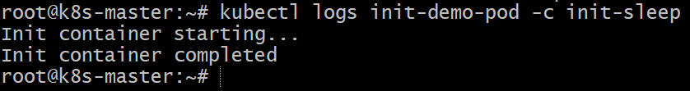

Step 5 : Verify Main Container Started

kubectl logs init-demo-pod -c main-container

You should see **nginx logs**, confirming the **main container started after init completion**.

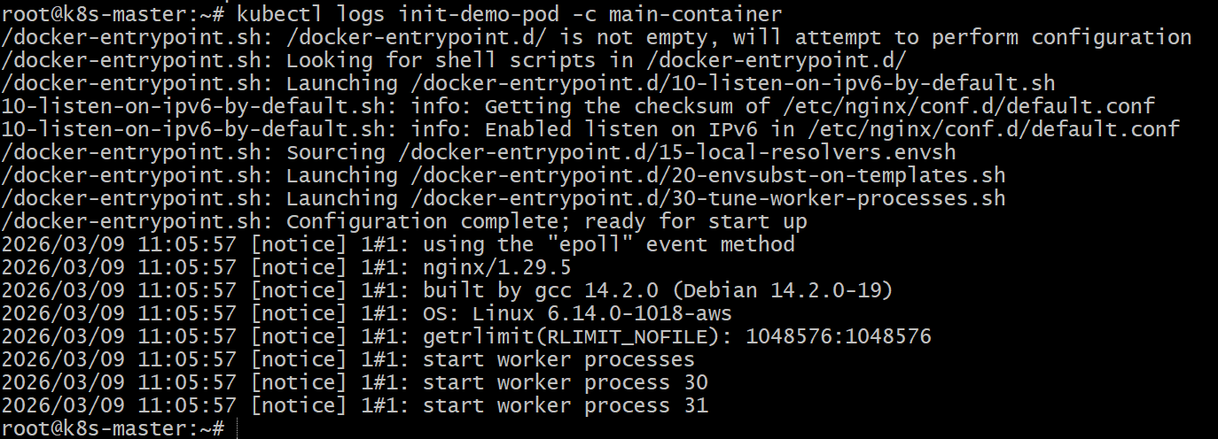

- Run a Dry Run Command to Generate YAML Task: Use the kubectl run nginx --image=nginx --dry-run=client -o yaml command to generate a Pod YAML definition. Modify the generated YAML to suit specific requirements (e.g., labels or environment variables) and deploy it.

Step 1 : Generate YAML Using Dry Run

Run the following command:

kubectl run nginx --image=nginx --dry-run=client -o yaml > nginx-pod.yaml

### What this does

* `kubectl run nginx` → creates a pod named **nginx**
* `--image=nginx` → uses **nginx container**
* `--dry-run=client` → **does not create the pod**, only simulates
* `-o yaml` → outputs the **YAML definition**
* `> nginx-pod.yaml` → saves it to a file

nginx-pod.yaml file will be created .

Step 2 : Modify the YAML

Now edit the file:

vi nginx-pod.yaml

Example modifications:

* Add **labels**
* Add **environment variables**

Modified YAML

apiVersion: v1
kind: Pod
metadata:
name: nginx
labels:
app: webserver
env: dev

spec:
containers:
- name: nginx
image: nginx
ports:
- containerPort: 80

env:
- name: APP_MODE
value: production
- name: APP_VERSION
value: "1.0"

restartPolicy: Always

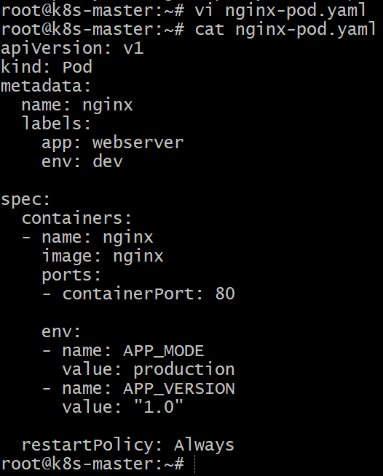

Step 3 : Deploy the Modified Pod

kubectl apply -f nginx-pod.yaml

Verify the Pod

kubectl get pods

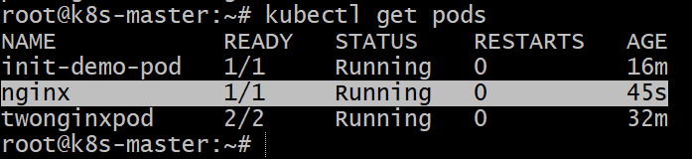

Describe pod to confirm labels and env variables:

kubectl describe pod nginx

You should see:

```
Labels: app=webserver
env=dev
Environment:
APP_MODE: production
APP_VERSION: 1.0
```

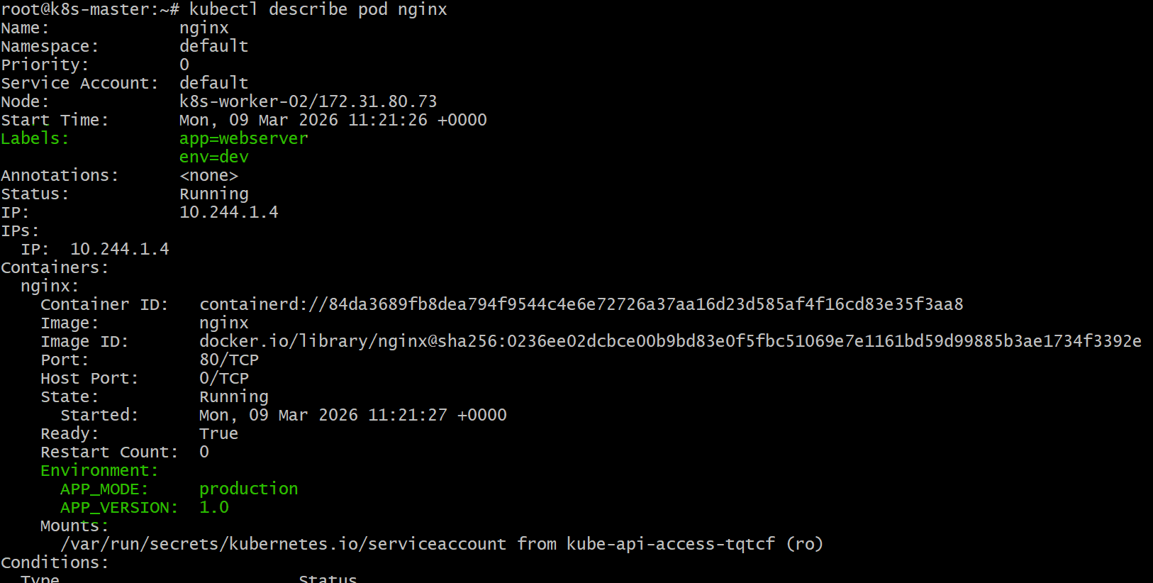

- Use kubectl apply vs kubectl create Task: Create a YAML file to define a Pod. First, deploy it using kubectl create -f <file_name>.yml and then modify the YAML (e.g., change the image version). Use kubectl apply to redeploy and verify the difference between both commands.

Step 1 : Create the Pod YAML File

vi pod.yaml

Paste the following YAML configuration:

apiVersion: v1
kind: Pod
metadata:
name: nginx-demo
labels:
app: nginx-demo
spec:
containers:
- name: nginx
image: nginx:1.23
ports:
- containerPort: 80

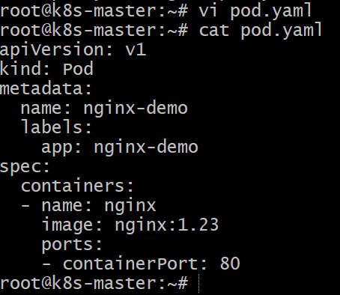

Step 2 : Deploy Using `kubectl create`

kubectl create -f pod.yaml

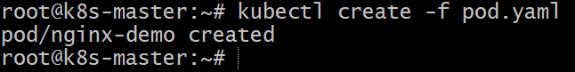

Verify:

kubectl get pods

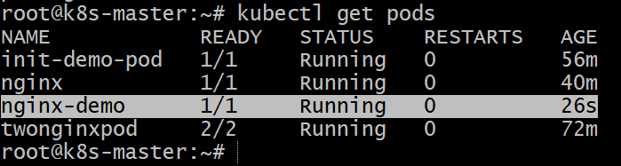

You should see:

nginx-demo 1/1 Running

Check the image used:

kubectl describe pod nginx-demo

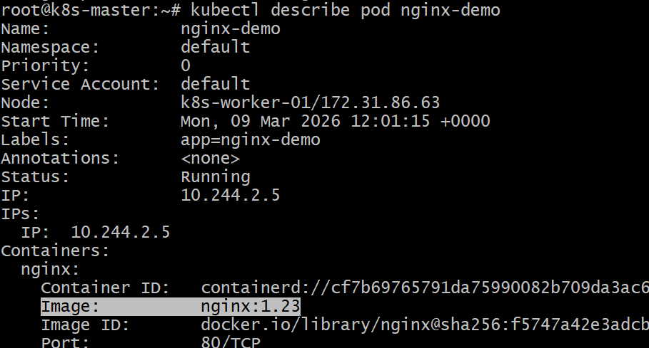

Step 3 : Modify the YAML File

Edit the file:

vi pod.yaml

Change the image version.

Updated YAML file

apiVersion: v1
kind: Pod
metadata:
name: nginx-demo
labels:
app: nginx-demo
spec:
containers:
- name: nginx
image: nginx:1.25
ports:
- containerPort: 80

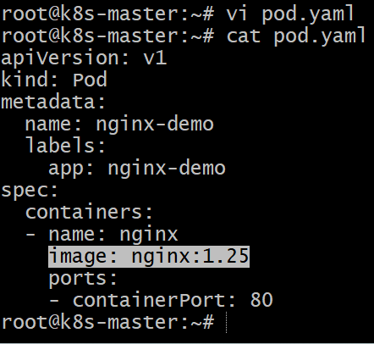

Step 4: Redeploy Using `kubectl apply`

kubectl apply -f pod.yaml

You may see an update message like:

pod/nginx-demo configured

Step 5 : Verify the Changes

Check again:

kubectl describe pod nginx-demo

Look for:

Image: nginx:1.25

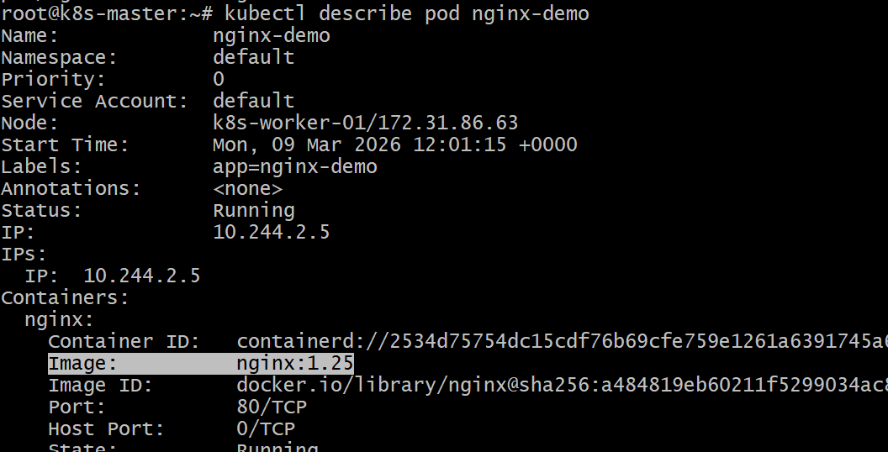

Difference Between `create` and `apply`

| Feature | kubectl create | kubectl apply |
| ---------------- | ------------------------ | ------------------------------------- |
| Purpose | Creates a resource | Creates or updates a resource |
| Re-run same file | Fails if resource exists | Updates existing resource |
| Use case | Initial creation | Continuous configuration management |
| State tracking | No | Yes (uses last-applied-configuration) |

- Edit an Existing Pod Configuration Task: Use kubectl edit pod <pod_name> to modify the running Pod's environment variables or image. After making the changes, verify if they took effect by checking the container logs or environment variables using kubectl exec.

# 1. Create a Pod First

vi nginx-pod.yaml

apiVersion: v1
kind: Pod
metadata:
name: nginx-edit-demo
spec:
containers:
- name: nginx
image: nginx:1.23
env:
- name: APP_ENV
value: development
ports:
- containerPort: 80

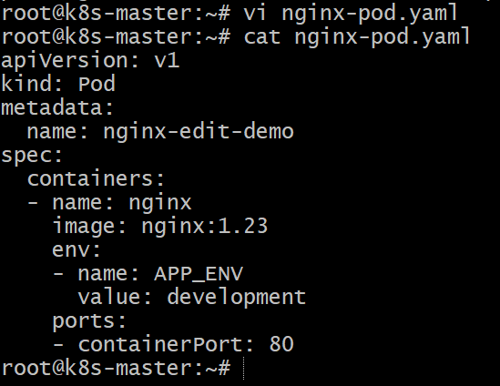
Deploy the Pod:

kubectl apply -f nginx-pod.yaml

Verify:

kubectl get pods

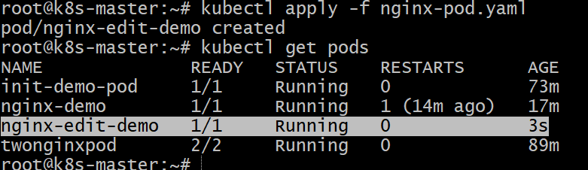

Step 2 : Edit the Running Pod

kubectl edit pod nginx-edit-demo

This opens the Pod configuration in the default editor (usually **vi**).

Step 3 : Modify the Configuration

Example changes:

### Change Image Version

Before:

```yaml
image: nginx:1.23
```

After:

```yaml
image: nginx:1.25
```

Step 4 : Verify the Changes

Check Pod Details

kubectl describe pod nginx-edit-demo

Look for:
Image: nginx:1.25
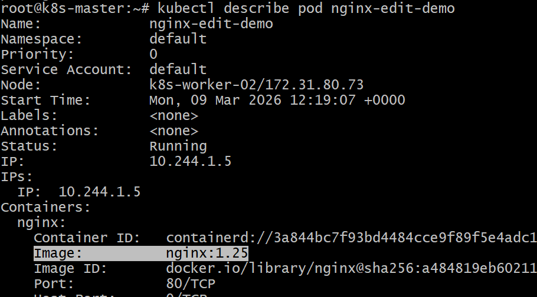

Step 5 : Check Container Logs

kubectl logs nginx-edit-demo

This confirms the container is running with the updated configuration.

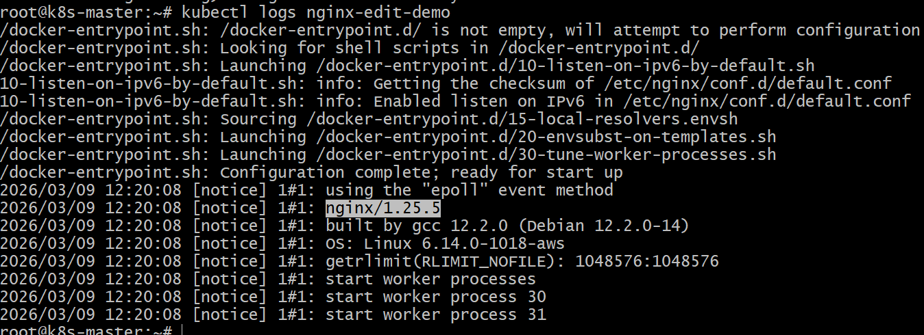

- Expose a Pod Using a Service Task: Create a YAML file to expose your firstpod using a Service (ClusterIP). Ensure that your service is exposing the Pod on port 80 and verify it using kubectl get svc.

Step 1: Create the Pod (firstpod)

vi firstpod.yaml

Paste the following in it :

apiVersion: v1
kind: Pod
metadata:
name: firstpod
labels:
app: myapp
spec:
containers:
- name: nginx-container
image: nginx
ports:
- containerPort: 80

Save the file.

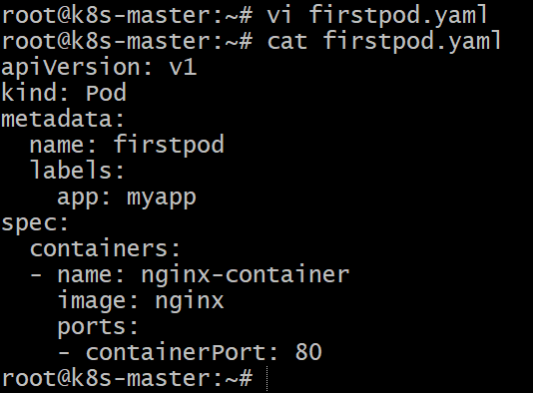

Step 2: Deploy the Pod

Run the following command:

kubectl apply -f firstpod.yaml

Verify the Pod is running:

kubectl get pods

Expected output:

NAME READY STATUS RESTARTS AGE
firstpod 1/1 Running 0 10s

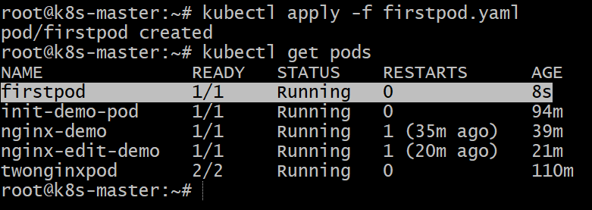

Step 3: Create a Service YAML

Create another file called **`firstpod-service.yaml`**

vi firstpod-service.yaml

Paste the following in it :

apiVersion: v1
kind: Service
metadata:
name: firstpod-service
spec:
type: ClusterIP
selector:
app: myapp
ports:
- protocol: TCP
port: 80
targetPort: 80

Explanation:

* selector: app: myapp → connects the service to the Pod label
* port: 80 → service port
* targetPort: 80 → container port

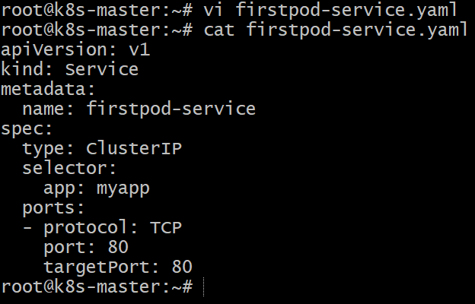

Step 4: Deploy the Service

Run:

kubectl apply -f firstpod-service.yaml

Step 5: Verify the Service

Check services:

kubectl get svc

Example output:

NAME TYPE CLUSTER-IP PORT(S) AGE
firstpod-service ClusterIP 10.96.45.10 80/TCP 5s

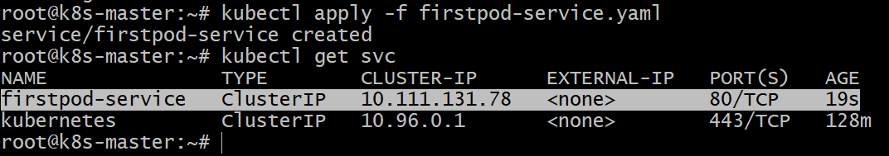

Step 6: Verify the Pod is Linked to the Service

Run:

kubectl describe svc firstpod-service

Look for Endpoints:

Endpoints: 10.244.0.5:80

This means the service is successfully pointing to the Pod.

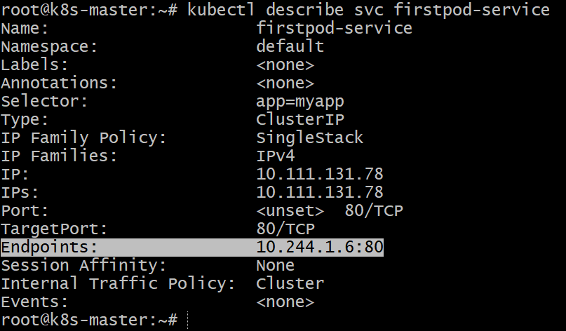

- Pod with Resource Limits and Requests Task: Add resource requests and limits to the containers in your YAML file. Specify CPU and memory requests/limits for both containers and deploy the Pod. Use kubectl describe pod to verify if the resource configurations are correctly applied.

Step 1: Create the Pod YAML with Resource Requests and Limits

Create a file called **`resource-pod.yaml`**

vi resource-pod.yaml

Paste the followoing it it :

apiVersion: v1
kind: Pod
metadata:
name: resource-demo-pod
spec:
containers:
- name: container1
image: nginx
resources:
requests:
cpu: "200m"
memory: "128Mi"
limits:
cpu: "500m"
memory: "256Mi"

- name: container2
image: busybox
command: ["sh", "-c", "while true; do echo running; sleep 10; done"]
resources:
requests:
cpu: "100m"
memory: "64Mi"
limits:
cpu: "300m"
memory: "128Mi"

Explanation

* requests → Minimum resources Kubernetes guarantees.
* limits → Maximum resources the container can use.
* `m` = millicores (1000m = 1 CPU)
* `Mi` = Mebibytes of memory.

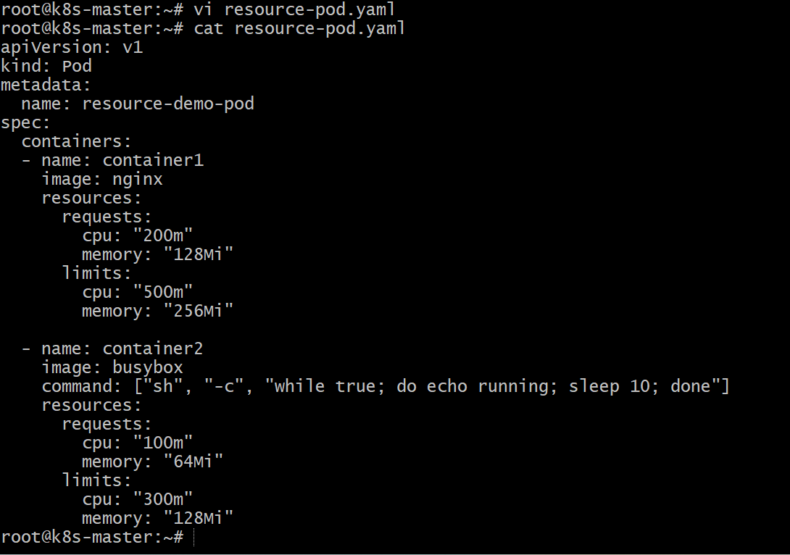

Step 2: Deploy the Pod

Run:

kubectl apply -f resource-pod.yaml

Step 3: Verify Pod Creation

Check if the Pod is running:

kubectl get pods

Example output:

resource-demo-pod 2/2 Running 0 20s

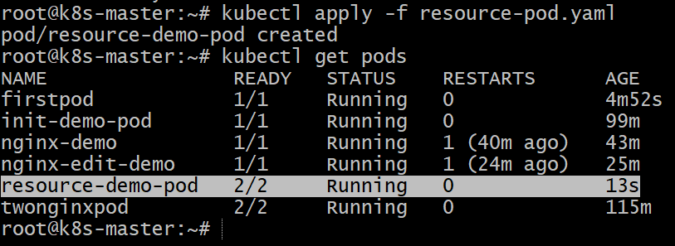

Step 4: Verify Resource Requests and Limits

Run:

kubectl describe pod resource-demo-pod

Look for the **Containers section**.

Example output:

```
Containers:
container1:
Image: nginx
Limits:
cpu: 500m
memory: 256Mi
Requests:
cpu: 200m
memory: 128Mi

container2:
Image: busybox
Limits:
cpu: 300m
memory: 128Mi
Requests:
cpu: 100m
memory: 64Mi
```

This confirms the **resource configuration is applied successfully**.

